LAB - 9

|  |  |
| --- | --- |
| Name | Keval D Gandevia |
| Roll Number | CE046 |
| ID | 19CEUEG017 |
| Subject | Image Processing |

**Aim:** Fourier Transform and frequency domain analysis in image processing.

**Q. 1: Preliminary: Implement DFT in MATLAB for 1 D array and use your script to perform the following DFT calculations: a. Input Sequence = [-2 2 -4 4] b. Input Sequence = [-4 -2 0 2 4].**

* **Code:**

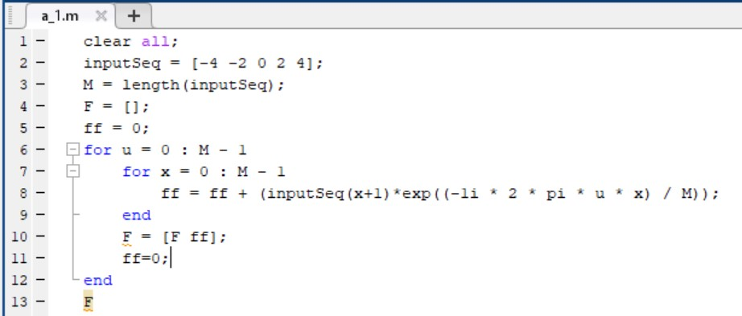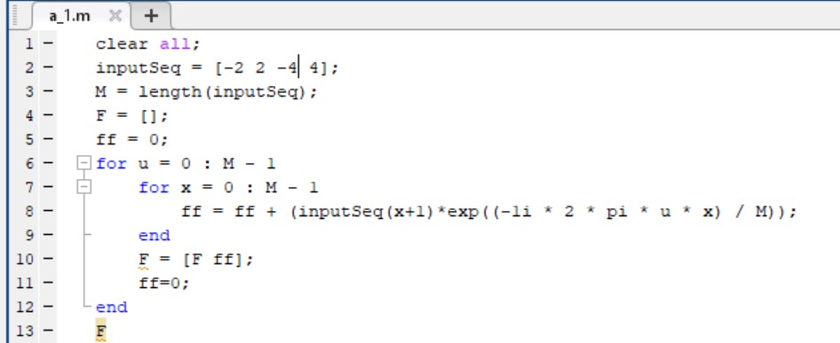

* **Output:**

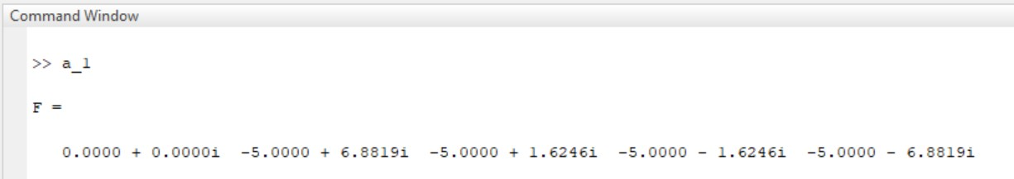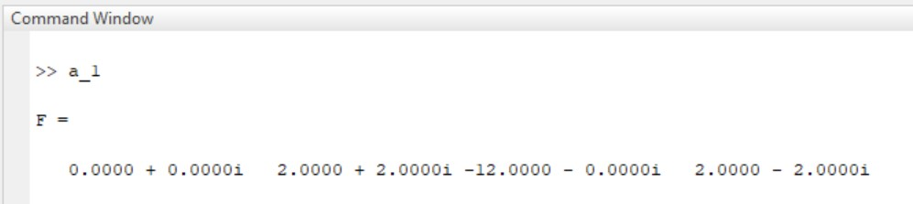

**Q. 2: The MATLAB routines for computing the 2-D DFT and the inverse 2-D DFT are the routines fft2 and ifft2. Using the image file cameraman.tif. Read in the image and perform DFT computations such that you get the following results.**

* 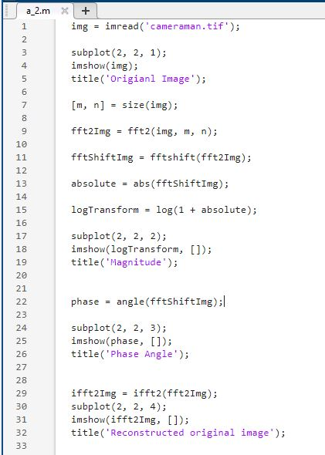**Code:**
* 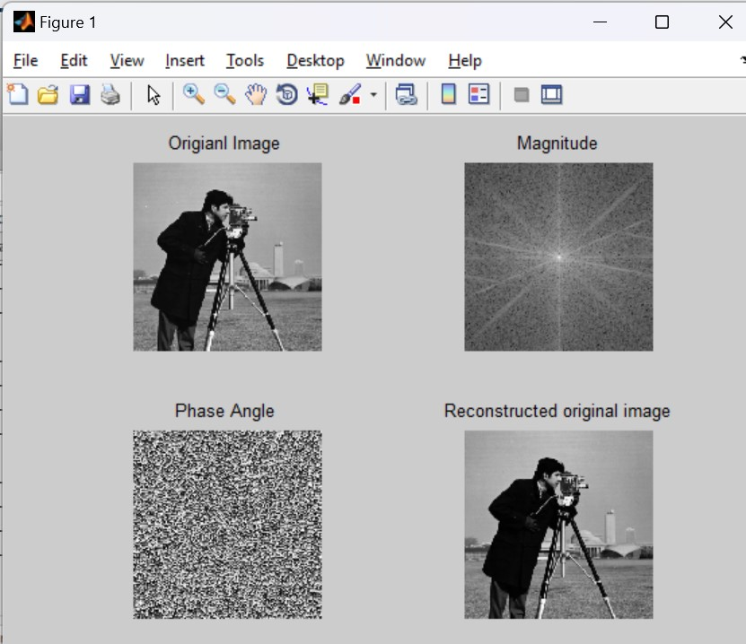**Output:**

**Q. 3: Use the image Rectangle.tif, validate a). If we translate the image using imtranslate ( ) by (x0, y0) = (100.0, - 150.0), then magnitude spectrum of the original and translated image remains the same. However phase angle changes. You should get approximately the following result b). If we rotate the image using imrotate ( ) by 45 degrees in clockwise direction, then magnitude spectrum as well as phase of the rotated image changes. You should get approximately the following result.**

* **Code with imtranslate:**

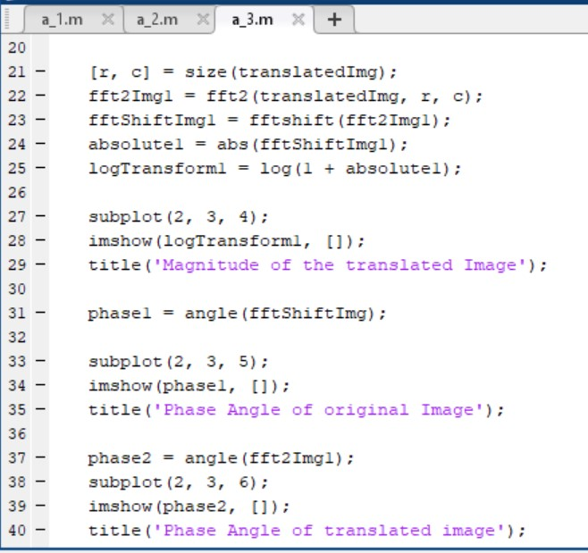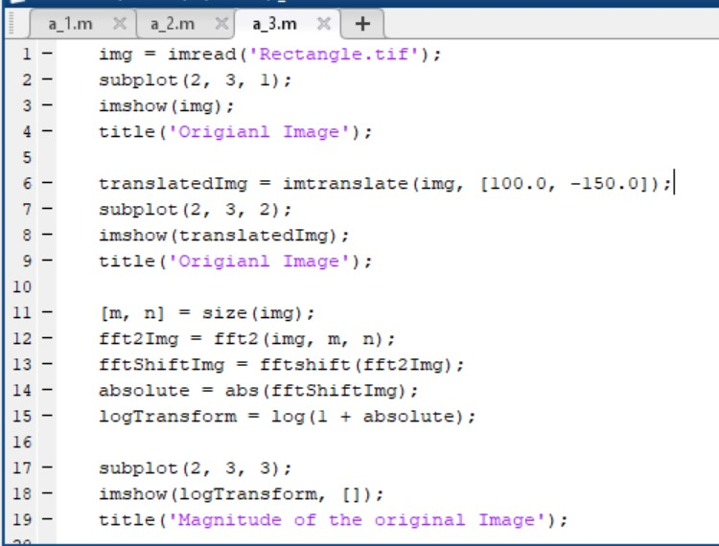

* **Output:**

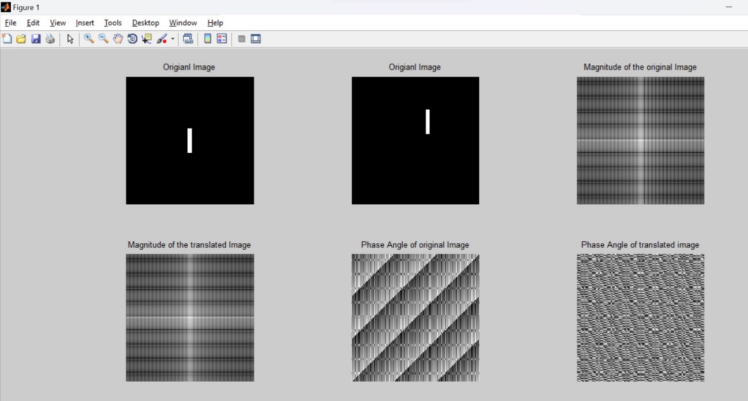

* 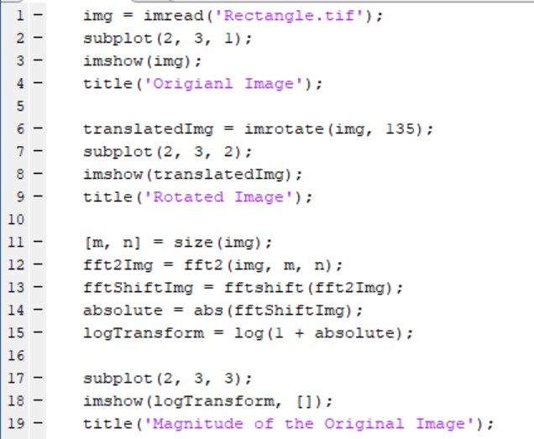**Code with imrotate:**

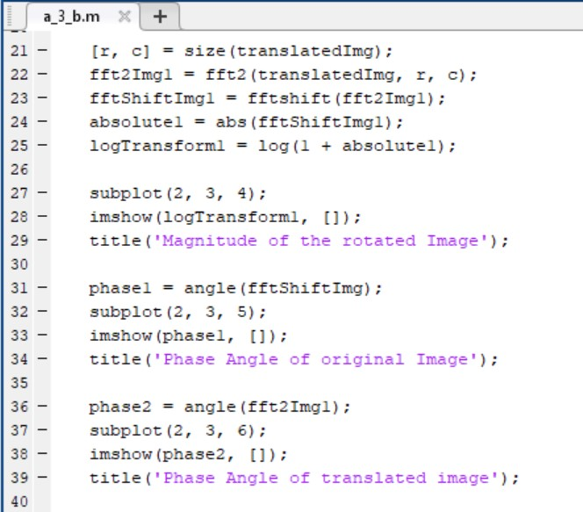

* 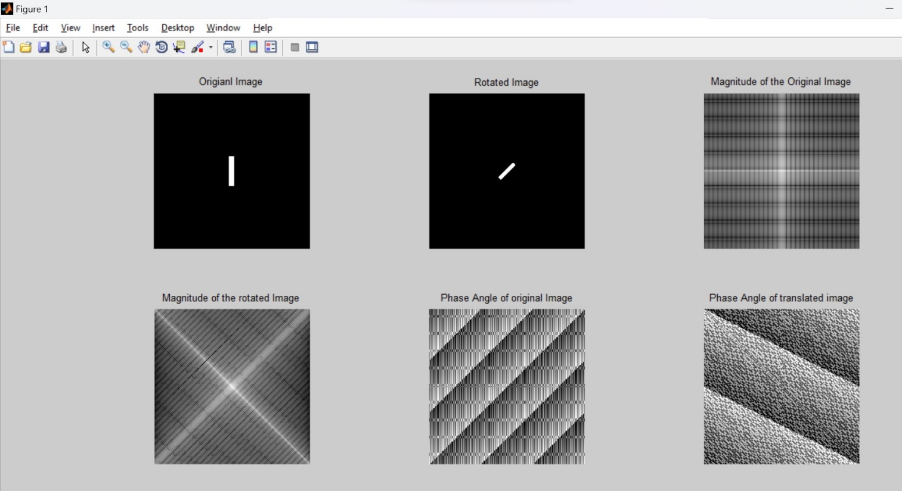**Output:**

**Q. 4: 4. Importance of DFT phase Using the image woman.tif and Rectangle.tif, perform 2D DFT and IDFT computations to get the following results. A). Phase angle of woman. B). Woman reconstructed using only the phase angle. C). Reconstruction using the phase angle corresponding to the woman and the spectrum corresponding to the rectangle. D). Reconstruction using the phase of the rectangle and the spectrum of the woman. E). Reconstruction using woman spectrum and phase. It should match the original image.**

* 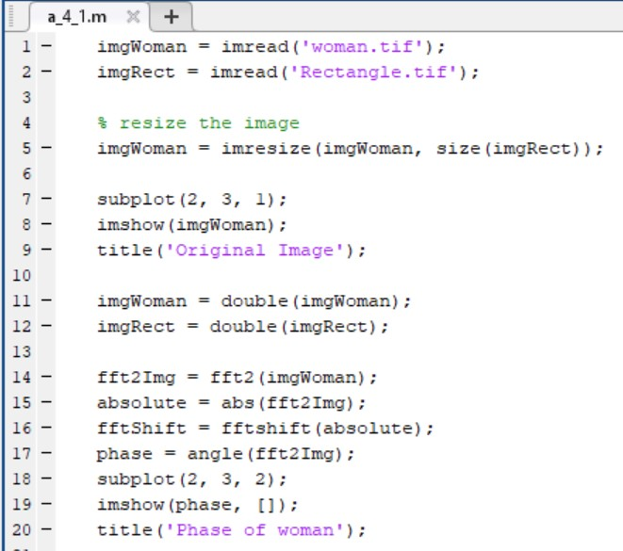**Code:**

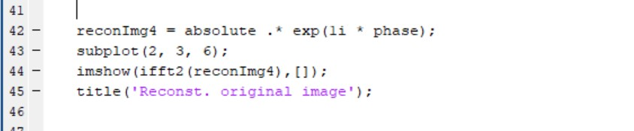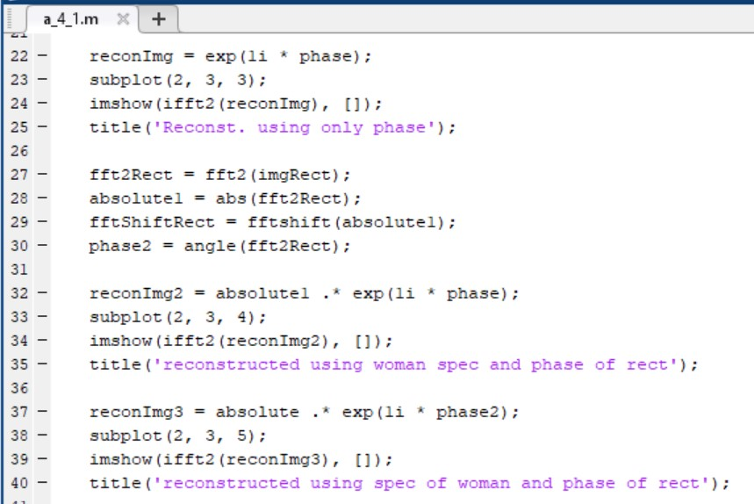

* 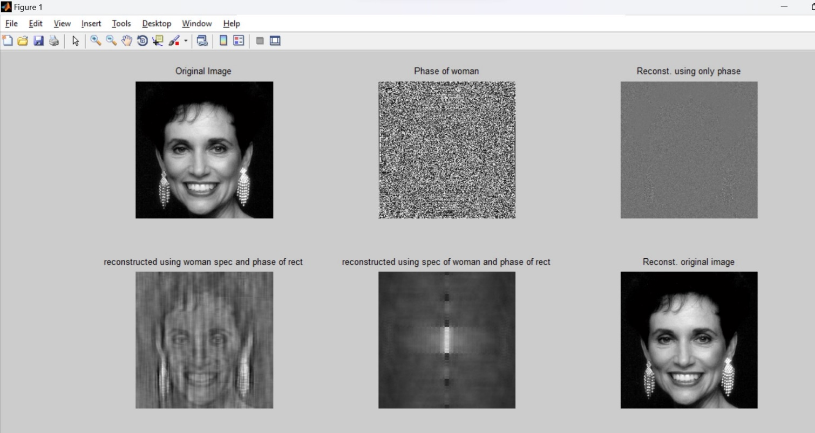**Output:**